Good Example
https://www.splunk.com/en_us/products/splunk-enterprise.html
This is the dashboard for splunk enterprise. This is a product made by CISCO and is pretty much the industry standard for cyber security analytics. It connects to a lot of different systems and is able to take all that information and put it into one place for easy understanding and visualization. It takes a lot of this information from log files from various systems like IDS/IPS (Intrusion detection/prevention system), personal computer logs, active directory information, and server logs. All this information is to much for anyone to make since of so splunk goes through it automatically and crunches the numbers into human readable dashboards like the one below. It also is designed to be accessible by different levels of management like the more technical team leads or VPs as well as having an executive view for the C-suite.
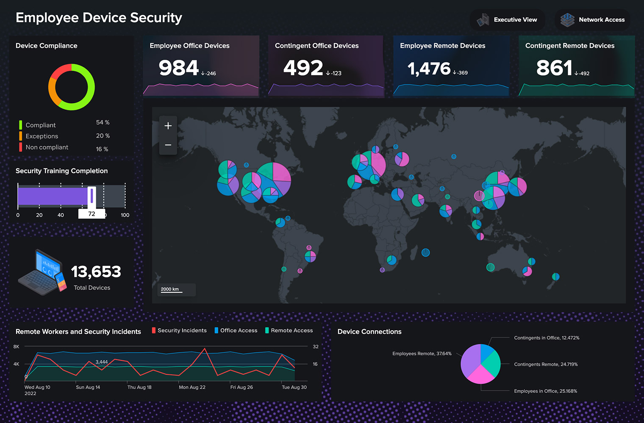
What makes splunk so good is the constant refinement that has taken place to make it easier to use and more visually appealing. This dashboard has a lot to unpack from it but still maintains a level of readability that most would fail to achieve due to overcrowding of information. To start every widget is either self-explanatory or has a key that makes it easily understood. The device compliance widget is perfect in that it has a circle showing the overview with the percentages and key directly under it. The Geographical heat map is on the boarder of being to much but for a professional it is probably perfect in that it can show locational trends and the colors coordinate with the charts directly above it. These charts are great for seeing trends based on your devices in order to see if your office devices are increasing or decreasing and in what places which might change how you do employee education or security rules. I also think that the fact that it has an executive view is perfect for showing the c-suite as this might be information overload for executives. The graph on the bottom right is also great for correlating remote workers and security incidents. The other thing that makes this dashboard so good is due to the long history of the product. Due to this it is compatible with a large range of devices. What makes these software programs so good is that they take a lot of information in automatically and it becomes very difficult to work with if it doesn’t connect with the systems your company has. That’s what makes splunk so good is because of its long history and large customer base it likely has compatibility for almost everything that is being used currently. Overall its pristine, clean, and concise look coupled with it’s long standing and great backend connectivity is what makes splunk the industry standard and is why this is a good example of cybersecurity analytics.

Bad Example
https://www.slideteam.net/cyber-attack-analytics-dashboard-with-level-of-security.html
This is a power point presentation designed to show analytics on a dashboard. You can find it on slide team and appears to be free to download. It comes with a lot of custom graphics that can be used to design your PowerPoint however you need to. It also seems that you can link it to an excel document to import data into the charts. It is advertised as 100% edible, saves hours of time, and will impress your audience. It uses a heavy dose of blue and pink to show the analytics at least on the dashboard slide that is advertised. It seems to have a couple of menus that you can click through as well as two charts and 4 pie charts on the bottom showing different information like incidents based on malware type, open tickets, and open incidents.
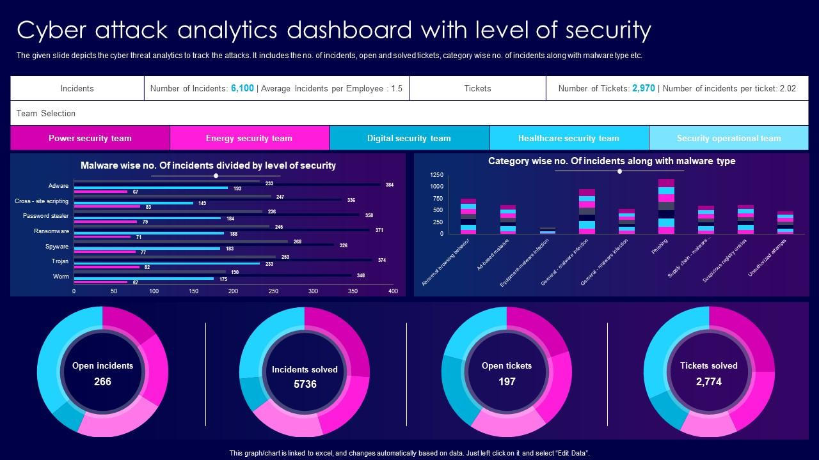
The first reason for why this is a bad example of cybersecurity analytics is the colors. The pink and blue is very overdone and honestly the colors aren’t explained anywhere on the dashboard. It also uses a lot of tiny font and numbers as well as grey and black for some statistics which doesn’t show up good at all. It also uses white text on the menu buttons which becomes extremely difficult to read on some of the brighter buttons. This is made for PowerPoint so some of the small things might be easier to view but the colors would definitely not pass a color accessibility test. The other thing about this that I don’t like is all the information likely needs to be manually inputted into a spreadsheet to be linked to these graphics and formatted in a specific way to interface properly with these graphics. So even if you had a tool capable of putting everything into excel you would need to spend a lot of time changing the way that data is inputted just to connect it to your PowerPoint graphics. This package things claims to save a lot of time but that alone would likely take hours to complete. Overall the visual representation of data is very poor and the backend work required to make this templet work is not designed very well and would be a major pain in the butt to make work.

References

Cyber attack analytics dashboard with level of security. SlideTeam. (n.d.). https://www.slideteam.net/cyber-attack-analytics-dashboard-with-level-of-security.html
Splunk enterprise. Splunk. (n.d.). https://www.splunk.com/en_us/products/splunk-enterprise.html

